 COMSATS University Islamabad, Lahore

Spring 2020
□ Sessional-1 □ Sessional-II □ Terminal Examination
Course Title: | Semantic Web (Theory) |  |  |  | Course Code: |  | CSE344 | Credit Hours: | 3(2,1)
Course Instructor/s: | Sana Rizwan |  |  |  | Program Name: |  | BSSE
Semester: | 7th | Batch: | FA17 | Section: | A/B |  | Date:
Time Allowed: | 50 minutes |  |  |  | Maximum Marks: |  |  | 35
Student’s Name: |  |  |  |  | Reg. No.
Important Instructions / Guidelines:
- Rewriting and cuttings are not allowed. All questions are compulsory.

Question 1: (Marks = 05)
Identify the principles of web, choose the correct answer, select option from the information bank.

(Openness, Accessibility, Nonproprietary, Consensual control, Usable, Interoperability, Decentralized authorship, Automated mechanisms for routing, Enabling n:m relationship, Proprietary)

- Participation of multiple person in organization will minimize the web cost even if they didn’t own it. ______________________________
- Headquarter control sometimes have to tolerate according to their disorganized strategies. ___________________________
- Expensive manual indexing was the main reason for the revival/ upgradation of bookmark list. ________________________________________________
- Usability of appropriate content in a straightforward manner, without any hurdle.____________
- Clients are open to access all the contents, never mind the operating system, software integration, hardware capabilities, network associations etc _________________________

Question 2: (Marks = 06)

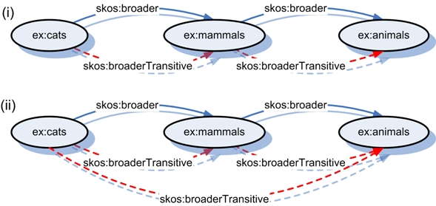

Identify the direct association validity using SKOS among classes. Remember that skos:broaderTransitive is a transitive superproperty of skos:broader.

According to diagram (i and ii), write your answer Valid / Invalid:
- ex:cats skos:broader ex:mammals _______________________________
- ex:cats skos:broaderTransitive ex:mammals _______________________
- ex:cats skos:broader ex:animals_________________________________
- ex:mammals skos:broaderTransitive ex:animals ____________________
- ex:mammals skos:broader ex:animals ____________________________
- ex:cats skos:broaderTransitive ex:animals_________________________

Question 3: (Marks = 13)

Complete Semantic Web Architecture Layered Diagram by filling data.

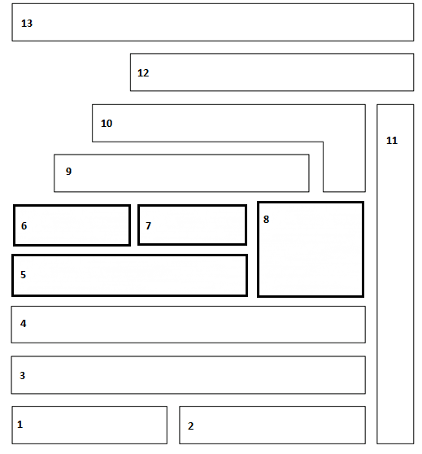
- RDF
- URI
- XML
- OWL DL
- RDFS
- NS
- OWLS
- Unicode
- OWL
- Trust
- SPARQL
- Proof
- SQL
- RIF
- Cryptography
- GUI
- URN
- Logic

Question 4: (Marks = 11)

Select the correct option.

- Use HTTP URIs so that people can look up names of things and for useful information use the standard (RDF, SPARQL) in _______________________.
- Data Integration
- Data Transformation
- Data Publishers
- Data Acquisition

- _____________________________ model decouples data providers from data consumers, allowing clients to use uniform interfaces for accessing and querying data stored on remote servers.
- RESTful
- D2R
- JSON
- REST

- What are the sequence of uniform resources given below;

http://example.org/mypictures/cat.png
ftp://example.org/mypictures/cat.png
URN:pin:bs4321234

- URI, URL, URN
- URI, URI, URN
- URL, URI, URN
- URL, URN, URI

- “John born in 2004”, identify the graph structure about the given data model.
- John ______________ (Object, Subject, Predicate)
- 2004 ______________(Object, Subject, Predicate)
- Born in ____________(Object, Subject, Predicate)

- _______________ facilitates the RDF vocabulary for expressing metadata about people, and their interests, relationships and activities.
- Turtle
- FOAF
- Redland
- ARP

- RDF documents will generally be in __________________.
- OWL DL
- OWL 2
- OWL Lite
- OWL Full
7) _____________________ is a sort of compromise between expressivity and scalability inspired by rule – based reasoning.
a. OWL 2 RL
b. OWL 2 QL
c. OWL 2 EL
d. None of the above

8) Select any two parsers to process RDF having featured libraries.

a. RDFa and XHTML
b. XML and Turtle
c. ARP and Redland
d. RDF and RDFS

SOLUTION PAPER:

Question 1: Identify the principles of web, choose the correct answer, select option from the information bank. (Marks = 05)
(Openness, Accessibility, Nonproprietary, Consensual control, Usable, Interoperability, Decentralized authorship, Automated mechanisms for routing, Enabling n:m relationship, Proprietary)
- Participation of multiple person in organization will minimize the web cost even if they didn’t own it. ( Nonproprietary)
- Headquarter control sometimes have to tolerate according to their disorganized strategies. (Decentralized authorship)
- Expensive manual indexing was the main reason for the revival/ upgradation of bookmark list. (Automated mechanisms are provided to route requests and responses)
- Usability of appropriate content in a straightforward manner, without any hurdle. (Usable)
- Clients are open to access all the contents, never mind the operating system, software integration, hardware capabilities, network associations etc (Accessibility)
Question 2: (Marks = 06)

Identify the direct association validity using SKOS among classes. Remember that skos:broaderTransitive is a transitive superproperty of skos:broader.
According to diagram (i and ii):
- ex:cats skos:broader ex:mammals _______________________________ V
- ex:cats skos:broaderTransitive ex:mammals _______________________V
- ex:cats skos:broader ex:animals_________________________________InV
- ex:mammals skos:broaderTransitive ex:animals ____________________V
- ex:mammals skos:broader ex:animals ____________________________V
- ex:cats skos:broaderTransitive ex:animals_________________________V

Question 3: Complete Semantic Web Architecture Layered Diagram by filling data. (Marks = 13)

- RDF
- URI
- XML
- OWL DL
- RDFS
- NS
- OWLS
- Unicode
- OWL
- Trust
- SPARQL
- Proof
- SQL
- RIF
- Cryptography
- GUI
- URN
- Logic

Solution:
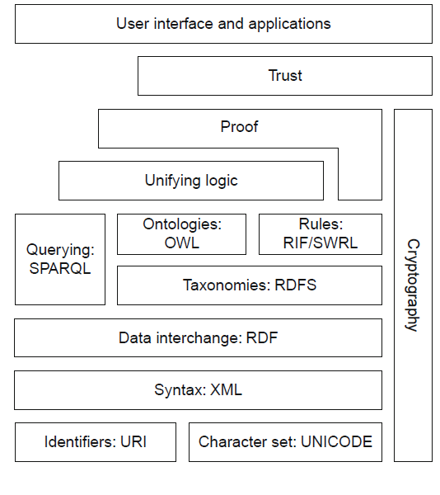
Question 4: (Marks = 11)
Select the correct option.
- Use HTTP URIs so that people can look up names of things and for useful information use the standard (RDF, SPARQL) in _______________________.
- Data Integration
- Data Transformation
- Data Publishers
- Data Acquisition
- _____________________________ model decouples data providers from data consumers, allowing clients to use uniform interfaces for accessing and querying data stored on remote servers.
- RESTful
- D2R
- JSON
- REST
- What are the sequence of uniform resources given below;

http://example.org/mypictures/cat.png
ftp://example.org/mypictures/cat.png
URN:pin:bs4321234

- URI, URL, URN
- URI, URI, URN
- URL, URI, URN
- URL, URN, URI

- “John born in 2004”, identify the graph structure about the given data model.
- John _____________ subject
- 2004 _____________Object
- Born in ____________Predicate

- _______________ facilitates the RDF vocabulary for expressing metadata about people, and their interests, relationships and activities.
- Turtle
- FOAF
- Redland
- ARP
- RDF documents will generally be in __________________.
- OWL DL
- OWL 2
- OWL Lite
- OWL Full
7) _____________________ is a sort of compromise between expressivity and scalability inspired by rule – based reasoning.
a. OWL 2 RL
b. OWL 2 QL
c. OWL 2 EL
d. None of the above
8) Select any two parsers to process RDF having featured libraries.
a. RDFa and XHTML
b. XML and Turtle
c. ARP and Redland
d. RDF and RDFS

